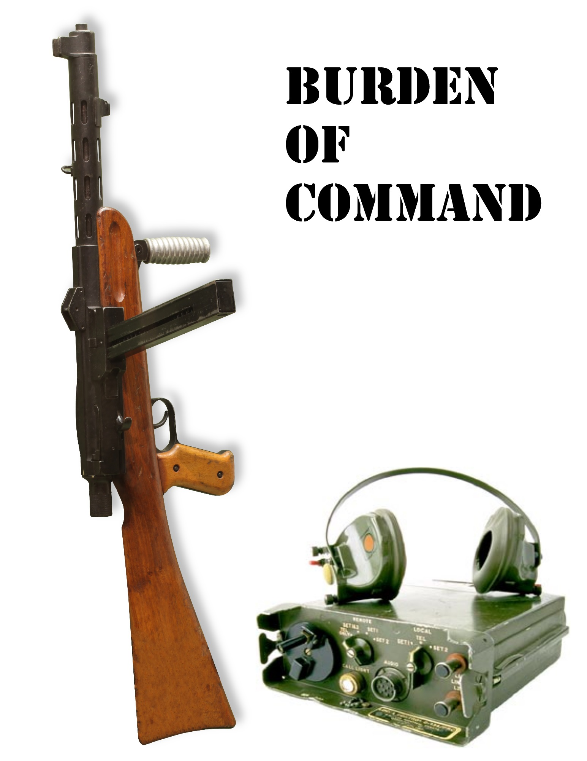

CGDD 4803/4814

Game Concept Doc

1/14/2014

Burden of Command

Austin Ford, Shawn Day, Joseph Jeanty

* **Intended Audience –** M (17+)
* **Length of Play –** 20 to 40 minutes
* **Intended Platform –** PC
* **Description –** Bringing down the house with a combination of FPS and RTS elements Burden of Command will challenge your reflexes and your strategic abilities.
* **Backstory –** As the world’s resources dwindle the armies of the earth are combined to form the United Nations Expeditionary Force. Searching for the necessities of life UNEF encounters forces of unparalleled power. As a commander and mech warrior you must balance the choices of leading from the front and commanding your troops across the battlefield. Will you use brains or brawn to win the Day!
* **User Experience** – The user will have two ways of commanding his forces, from a command center or from the front with the troops. In the command center the player will enter Command Mode, which transforms the game into a strategy game. In this mode the player can build bases, train troops and issue orders. Leading from the front will play like a FPS game, allowing the player to mow down the enemies alongside their troops. To win the day requires the destruction of all enemy forces or capturing their command center. If the player dies at any point, they can be brought back to life but will cost large sums of resources.
* **Asset List** :

- Each unit will require: 1x 3D Model, 1 2D image, gunfire sound effect, and idle, walk/run, shooting and death animation.

-Each building will require: 3x 3D Models, 1x 2D image.

-The HUD requires: 1x 2D image.

-The menu will require: 10 button images.

* **Cost Estimation** – We estimate that the development of this game will cost $115,00. We got this number by estimating we will need 2 programmers, each being paid $6.5k a month, one designer being paid $5k a month, one artist being paid $5k a month, and one sound engineer being paid $5.7k a month. We estimate the development time to be 4 months. 